**Barron’s Let’s Review Regents – Algebra II**

# Chapter 10: Standard Deviation

## 10.1 Standard Deviation

**Key Ideas**

The *standard deviation* of a set of numbers is a measure of how “spread out” the numbers in a set are. The more spread out the numbers are, the larger the standard deviation.

**Comparing Standard Deviations for Two Data Sets with the Same Mean**

Two rooms each have 100 people in them. The mean (average) height of the people in each room is approximately 66 inches. Even though the rooms have the same number of people and the same mean, there is something very different about the collection of people in each room. Below are the dot plots for room 1 and room 2.

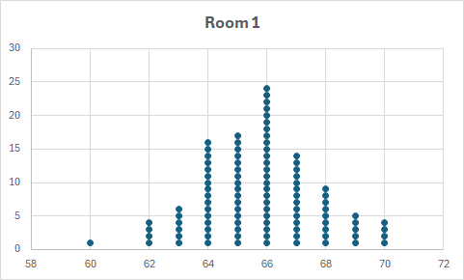

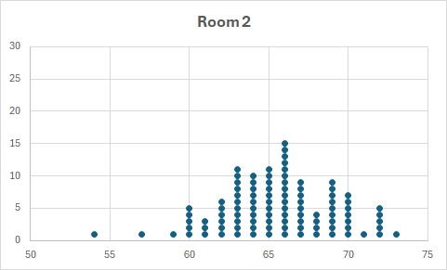

The people in room 1 are mostly very close to the 66-inch average. There are people in room 2, though, who are much shorter than the average and people who are much taller than the average.

In statistics, we say that the set of people in the second room have a higher standard deviation. The standard deviation for the heights of the people in the room 1 was approximately 2, while the standard deviation for the heights of the people in room 2 was 6.

**Example 1**

Each of the dot plots below has a mean of approximately 40. Which of the dot plots below corresponds to the set with the lowest standard

**Calculating Standard Deviation with Microsoft Excel**

Excel has built-in functions like AVERAGE for the mean and STDEV.S (for sample standard deviation) or STDEV.P (for population standard deviation) to calculate these values directly.

**Calculating Standard Deviation with Microsoft Edge Add-ons**

[Standard Deviation Calculator](https://microsoftedge.microsoft.com/addons/detail/standard-deviation-calcul/cgobbibhehfoedopeahebikmmdkahlfc?hl=en-US)

**Calculating Standard Deviation with Omni Calculator**

[Omni Calculator](https://www.omnicalculator.com/statistics/z-score), which can calculate both mean and standard deviation.

**Calculating Mean and Standard Deviation with Geogebra**

[One Variable Stats on Geogebra](https://www.youtube.com/watch?v=jcXKwU3O6Po)

1. Use Geogebra Classic.
2. Select Spreadsheet view.

1. Copy data from Spreadsheet column into Geogreba Spreadsheet column(s). Delete the first row if it contains a header (necessary?)

1. Click One Variable Analysis tool.

1. Select One Variable Analysis menu button.

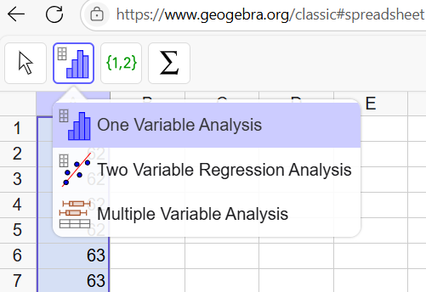

1. A histogram is displayed. Click the button.

The mean and standard deviation is displayed.

**Standard Deviation for Sets with Repeated Numbers**

Entering all the numbers for a large data set into the calculator can be very time consuming. If however, there are many repeated numbers, you can use a shortcut. Below the data for 55 numbers are summarized in a *frequency table*. The 7 in the frequency column after the number 42 means that there are seven 42s in the data set.

|  |  |
| --- | --- |
| **Number** | **Frequency** |
| 42 | 7 |
| 53 | 9 |
| 61 | 12 |
| 74 | 8 |
| 86 | 4 |
| 127 | 10 |
| 150 | 5 |

**Using Microsoft Excel to Create Histogram Using Frequency Table**

1. Select the table in Excel

1. On Insert Tab, select Recommended Charts. Select Clustered charts.

1. Select + button followed by clicking checkbox for Axis Titles. Horizontal and Vertical axis title regions appear.

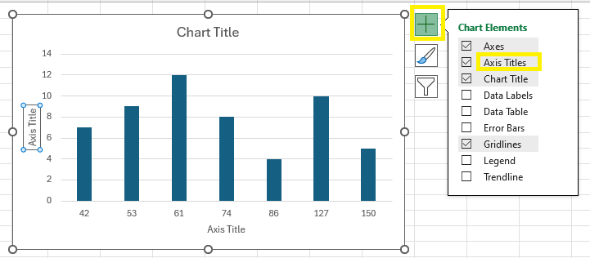

1. Type in Numbers for Horizontal axis title and Frequency for Vertical axis title. Change the Chart Title to Number Frequency or Number Histogram.

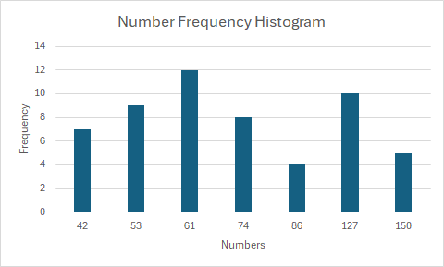

**Using** [**GeoGebra Calculator Classic**](https://www.geogebra.org/classic)

1. Click on above link for GeoGebra Calculator Classic.
2. Click Spreadsheet option. Refresh browser page if this does not appear.

1. Copy and paste table data from Word, Excel or Comma Separated Value file using Hamburger menu bar. If opening Command

1. Select both columns. Click Histogram button. Click One Variable Analysis

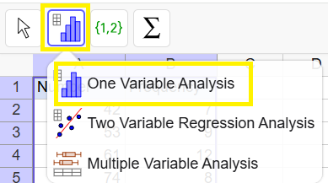

1. Select Bar Chart.

1. Clicking on the bar chart displays some display options, such as setting the bar width.

1. Statistics can be displayed by clicking the Sigma x button.



The mean, population standard deviation , sample standard deviation, minimum, maximum, median and quartiles are displayed, among other items.

**z-scores**

In a data set with a mean of 60 and a standard deviation of 4, the number 64 is one standard deviation above the mean since it is equal to the mean plus the standard deviation. The number 68 is two standard deviations above the mean since it is equal to the mean plus two times the standard deviation .

In statistics, we say that a number that is one standard deviation above the mean has a *z-score* of 1, while a number that is two standard deviations above the mean has a z-score of 2.

**Math Facts**

The *z-score* of a number is how many standard deviations above or below the mean that number is. If the number is greater than the mean, the z-score is positive. If the number is less than the mean, the z-score is negative.

A formula for calculating z-score is   
.

**Example 3**

If the mean is 60 and the standard deviation is 4, what is the -score of the number 52?

*Solution*: Since 52 is less than 60, the -score will be negative. For this example, it is possible to subtract the standard deviation, 4, from 60 to get to 56, which has a -score of -1. Then subtract it again to get to 52, which has a -score of -2.

This can also be calculated with the formula   
.

**Example 4**

If the mean is 40 and the standard deviation is 7, what is the -score of the number 50?

*Solution*: The -score must be between 1 and 2, since while would have a -score of 2.

Use the formula:

**Example 5**

If the mean is 73 and the standard deviation is 8, what number has a -score of -1.5?

*Solution*: Multiple the -score by the standard deviation to get . Add this to the mean to get , which is the number that has a -score of -1.5.

This can also be done with the formula with as a known variable and the number is unknown.

### Check Your Understanding of Section 10.1

1. *Multiple-Choice*
2. Each of these data sets has a mean of 5. Which has the smallest standard deviation?

**(3) 4, 5, 5, 5, 6**

1. What is the standard deviation of the data set 16, 19, 14, 12, 10, 15, 15, 16  
   A screenshot of a spreadsheet

   AI-generated content may be incorrect.  
   **(1) 2.5**
2. What is the standard deviation for this data set?

|  |  |
| --- | --- |
|  |  |
| 18 | 4 |
| 19 | 7 |
| 20 | 2 |
| 21 | 3 |
| 22 | 6 |

**(2) 1.51**

1. If the mean of a data set is 60 and the standard deviation is 8, what is the z-score for the number 72?  
   **(4) 1.50**
2. If the mean of a data set is 40 and the standard deviation is 6, what number has a -score of -2.5?  
   **(1) 25**
3. Which number has a -score closest to -1 in in the data set 45, 38, 47, 41, 42, 34, 46, 37?  
   A screenshot of a computer

   AI-generated content may be incorrect.  
   **(4) 37**
4. If the mean of the data set is 41 and the standard deviation is 6, which of the following has a -score between 1.5 and 2.0?  
   **(4) 51**
5. How many of these 8 numbers are more than two standard deviations from the mean?

18, 40, 44, 45, 48, 50, 50, 68

18 is the only number more than 2 standard deviations away.  
**(1) 1**

1. How many of these 8 numbers are more than two standard deviations from the mean?

11, 49, 52, 52, 53, 53, 55, 90  
11 more than 2 std dev

**(1) 1**

1. What percent of these 14 numbers have a -score between -1 and +1?

59, 62, 54, 58, 62, 62, 55, 56, 65, 64, 58, 53, 59, 61

Outside of range: 54, 55, 65, 64  
Inside range:

**(2) 71%**

## 10. 2 Normal Distribution

**Key Ideas**

The dot plot of real-world data has the shape of a bell curve, which is also known as a *normal distribution* curve. When this happens, it is possible to answer certain questions about the data that you would not be able to, had the shape of the dot plot not been a bell curve.

**The Normal Curve**

Below is a dot plot with 400 data points representing the weights of 400 children. The mean value is approximately 60, and the standard deviation is approximately 4.

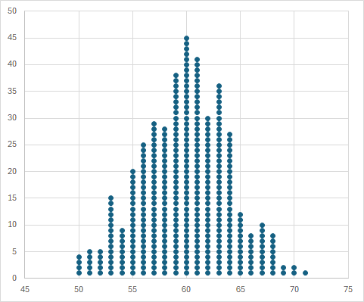

Since the mean is 60 and the standard deviation is 4, a score of 64 is said to be *one standard deviation above the mean*. A score of 68 is said to be *two standard deviations above the mean*. A score of 56 is said to be *one standard deviation below the mean*. A score of 52 is said to be *two standard deviations below the mean*.

**Percentages in the Normal Distribution Curve**

In a normal distribution with a lot of data points, approximately 68% of the values will be between one standard deviation below the mean and one standard deviation above the mean. 95% of the values will between two standard deviations below the mean and two standard deviations above the mean.

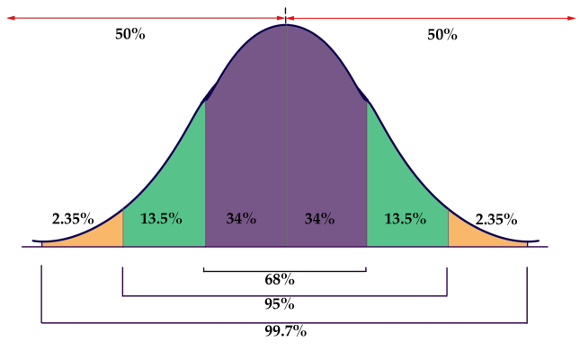

Using a Calculator to Find the Percentage of Numbers Between Two Values

If the mean and the standard deviation of a data set are known, the graphing calculator can quickly determine what percent of the numbers in the data set will be between any two values.

The heights of 400 people are measured. The mean is approximately 60, and the standard deviation is approximately 4.

Since 68% of the numbers are expected to fall within one standard deviation of the mean, then approximately should be between inches and inches.

Knowing the 68% and 95% rule is useful if a question asks how many members of a set are within one or two standard deviations of the mean. Most questions, though, are about finding how many members of a set are between two numbers that are not exactly one or two standard deviations from the mean.

In the scenario above, a graphing calculator can be used to determine how many out of the 400 people can be expected to be between 57.5 and 62 inches tall. Between 56 and 64 inches was 68% since those were the numbers exactly one standard deviation above and below the mean. The percent of people between 57.5 and 62 inches will be lower than 68% and can be found with a graphing calculator.

**Example 1**

If the mean of a set of Regents scores is 80, the standard deviation is 15, and the data are approximately normally distributed, approximately how many scores can be expected between 74 and 89?

Solution: The percent of scores between 74 and 89 will be approximately 38%. Out of 500 scores, this will be approximately scores.

**Example 2**

If the mean temperature in New York throughout the year is 55 degrees and the standard deviation is 15 degrees, what percent of the days can be expected to have temperatures greater than 80 degrees?

*Solution*: In this example, there is no upper bound? When this happens, make the upper bound a very large number, at least 4 standard deviations above the mean. (The number 9,999 is generally safe to use unless there is a very large mean and/or standard deviation.) When using 9,999 as the upper bound, the calculator determines the percent to be approximately 5%.

For examples, where there is no low bond, make the lower bound a very small negative number like -9,999.

Simulation using Python, Numpy and a sample size of 10,000 data points generated using a normal distribution with a mean of 55 degrees and a standard deviation of 15.

### Check Your Understanding of Section 10.2

My answers may be inaccurate due to the lack of a   
TI-84 calculator.

1. *Multiple-Choice*
2. If the mean of a set of normally distributed 200 numbers is 70 and the standard deviation is 6, approximately what percent of the numbers will be between 64 and 76?  
   **(1) 68%**
3. The weights of 400 children are collected, and the data are normally distributed. What percent of the children were between 42 and 52 pounds if the mean was 50 pounds and the standard deviation was 3?  
   **(4) 74%**
4. On the Algebra II Regents, the mean score was 75 and the standard deviation was 9. If the data was normally distributed, what percentage of the scores were over 90?  
   **(4) 5%**
5. The amount of time that 300 adults each week was collected. If the data were normally distributed, what percent of the people exercised under 20 minutes a week if the mean was 40 minutes and the standard deviation was 15?

**(1) 9%**

1. In a normally distributed data set, what percent of samples will have a -score between 1 and 2?

z-score 1: 68% - half is 34%

z-score 2: 95% - half is 47.5%

Difference: 13.5%

**(1) 14%**

1. In a set of 500 samples, the mean is 90 and the standard deviation is 17. If the data is normally distributed, how many of the 500 are expected to have a value between 93 and 101?

**(3) 86**

1. In a high school, 1,000 students run a mile. The mean time is 9 minutes with a standard deviation of 2 minutes. What running time would put a student in the top 5 percentile rank?

**(4) 5.8 minutes**

1. A group of baseball players had a mean of 15.3 home runs with a standard deviation of 9.9. If the data are normally distributed, what percentage of players can be expected to hit over 30 home runs?

**(3) 7%**

1. The average snowfall in Regents Town is 19 inches per year with a standard deviation of 5 inches. If the data are normally distributed, what is the probability that it will snow between 18.5 and 19.5 inches in a year?

**(2) 8%**

1. In a normally distributed data set with a mean of 60, what is more likely: a number greater than 80 or a number less than 30?

80 – 60 = 20

60 – 30 = 30

**(1) A number greater than 80**